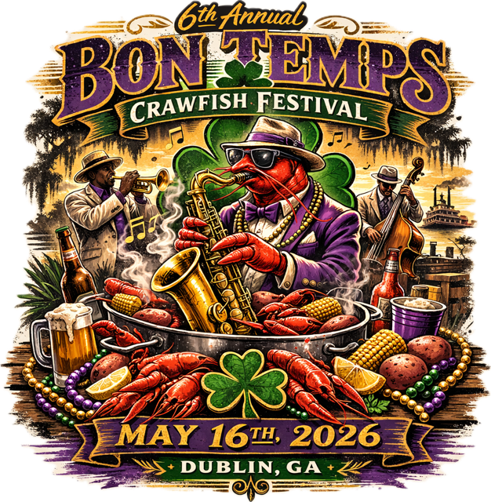

We’re excited to bring back the 6th Annual Bon Temps Crawfish Festival, May 16, 2026, a celebration of great food, live music, and lots of fun in Downtown Dublin. New this year: Miss Crawfish Festival Pageant (May 9), Crawfish Coloring Contest (May 1-8), & Crawfish Eating Contest (during Festival). This event is the perfect opportunity to showcase your support for the community while enjoying the festivities. Please join us and be a part of this much-anticipated tradition!

EXCLUSIVE PRESENTING SPONSOR (ONE PER EVENT): $5,000 - FILLED
- Recognition as Exclusive Presenting Sponsor with prominent logo/name placement in all advertising, including radio, print, television, & social media - including t-shirts.
- Opportunity for spokesperson of company to be featured in radio advertisement
- Placement of sponsor's logo, name, and link on Downtown Dublin website.
- Onstage recognition at the festival.
- Option of corporate booth at the festival.
- 20 event t-shirts & wristbands
PLATINUM SPONSOR: $2,500
- Prominent logo/name placement in all advertising, including radio,
print, television, & social media - including t-shirts.
- Exclusive logo placement on Crawfish Festival wristbands
- Onstage recognition at the events.
- Option of corporate booth at event.
- 10 event t-shirts & wristbands
GOLD SPONSOR: $1,000
● Logo/name featured in all print, radio, and social media advertising - including t-shirts.
● Placement of sponsor's logo and name on website
● 5 event t-shirts & wristbands

SILVER SPONSOR: $500
● Logo placed in all print and social media advertising - including t-shirts.
● 2 event t-shirts & wristbands

2026 Bon Temps Crawfish Festival Sponsorship Commitment Form

Count Us In!
___ Platinum Sponsor $2,500
___ Gold Sponsor $1,000
___ Silver Sponsor $500
Total Sponsorship Amount: $ _____________

____ Payment enclosed
____ Invoice me for the total amount.
____ Please contact me to discuss payment and/or in kind options.
Business _____________________________________________________ Contact Name________________________________
Email_____________________
Address______________________________________________
City_______________________ State_______ Zip___________
Phone________________________
Thank you for supporting the Downtown Development Authority. Your sponsorship is a tax deductible donation. Our federal tax ID is 45-488-3296. Please make checks payable to DDA and mail to 314 Academy Avenue, Dublin, GA 31021. For questions, please call 478-272-2560.

